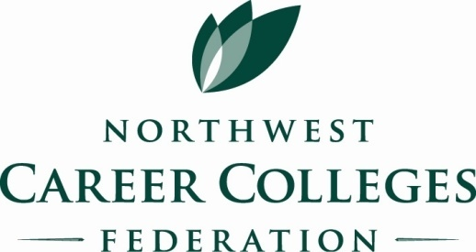
Making it easy for schools to find you…

Industry Partner is a good investment

Industry Partner Application

Indicate membership investment level: □ Platinum ($2,500) □ Gold ($2000) □ Associate (500)

Company Name_____________________________________________________________

Contact ___________________________________________________________________

Mailing address_____________________________________________________________

City___________________________________ State______________ Zip _____________

E-mail address______________________________________________________________

Phone ( ) ________________________ Fax ( ) _______________________________

Web site address ____________________________________________________________

Please provide a description of the services offered by your company. This information will be used on the NWCCF web site to describe Industry Partners’ resources and services.

Please check those areas of interest to you:
□ Display at the annual conference □ Speaker Opportunities
□ Notice of upcoming workshops or social events □ Sponsor a workshop presenter

□ Check is enclosed for $________________, made payable to NWCCF
□ Visa/AMEX/Master Card Account # _______________________________________________________
Expiration Date __________________ Security code ___ ___ ___

Signature _________________________________________________________Date____________

4200 6th Ave. SE, Suite 313 – Lacey, WA 98503
Ph. 360-292-4798 www.nwcareercolleges.org
The NWCCF is a non-profit 501(c)(3) Washington corporation

