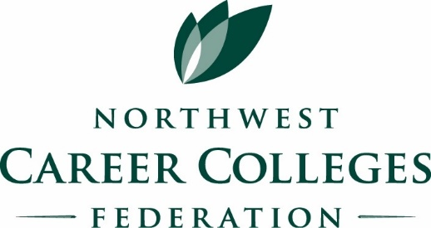
Make it easy for schools to find you
Maximize your networking opportunities
Reach three states with one membership!

Become an Industry Partner

At the Platinum Level For your $2,500 investment you’ll receive:

- One year featured as an “Industry Partner” with rotating logo on the NWCCF home page
- “Industry Partner” listing for one year on our website
- Priority placement if exhibiting at the Annual Conference
- Preliminary mailing for first option on sponsorships and display opportunities at the conference
- Notification for workshop sponsorship and display opportunities
- Opportunity for seminar delivery (web or on-site)

At the Gold Level For your $2,000 investment you’ll receive:

- “Industry Partner” listing for one year on our website
- Priority placement if exhibiting at the annual conference
- Preliminary mailing for sponsorship and display opportunities at the conference
- Notification for workshop sponsorship and display opportunities
- Opportunity for webinar

At the Associate Level For your $500 investment you’ll receive:

- “Industry Partner” listing for one year on our website
- Preliminary notice for sponsorship and display opportunities at the conference
- Notification of workshop sponsorship and display opportunities
- Better placement for display at annual conference

Northwest Career Colleges Federation
8300 28th Court NE, Suite 400 – Lacey, WA 98516
Phone 360-292-4798
Visit our website at:
www.NWCareerColleges.org

