MEMBERSHIP

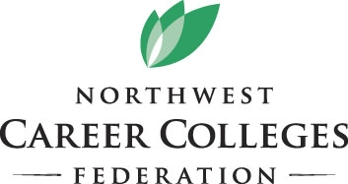
APPLICATION
8300 28th Court NE, Suite 400, Lacey, WA 98516
Phone: 360-292-4798
www.NWCareerColleges.org

Serving Idaho, Oregon and Washington private career colleges

I. Name of school ___________________________________________________________________________________________

Address _________________________________________________________________________________________________

City_____________________________________________________________ State ________ Zip _______________________

Phone ( ) __________________ Fax ( ) __________________ E-mail ________________________________________

Web site ________________________________________________________________________________________________

II. Primary Contact __________________________________________________________________________________________

Title _____________________________ E-mail address, if different from above _________________________________

III. Type of ownership: ( ) Sole proprietorship ( ) Corporation ( ) Non-profit
( ) Publicly traded ( ) Other

PAYMENT INFORMATION

Check enclosed made payable to NWCCF

- Please charge my credit card $_______

(VISA/ Mastercard/AMEX)
Number_________________________________
Exp. Date _______________________________
Security Code __ __ __
Name on Card:
________________________________________
Cardholder Billing Address:
Street ___________________________________

City_________________________ St______
Zip___________

Card Holder Signature:

________________________________________

Credit card payment/member information may scanned/emailed to exec@nwcareercolleges.org

Owner ____________________________________ How long? ___________

Address ________________________________________________________

City______________________________State ______ Zip _______________

- Check all agency approvals that apply:

- Licensed by the Workforce Training & Education Coordinating Board
- Oregon Higher Education Coordinating Commission
- Registered with Idaho State Board of Education
- Licensed by Idaho Bureau of Occupational Licensing
- Licensed by the Washington Department of Licensing
- Authorized by the Washington Higher Education Coordinating Board
- Approved for Veterans Training
- Accredited. List agency__________________________________
- Approved, U.S. Department of Education, SFA Title IV programs
- Other:

I hereby attest that all information provided with this application is accurate to the best of my knowledge.

Signed _________________________________________________________________ Date________________________

