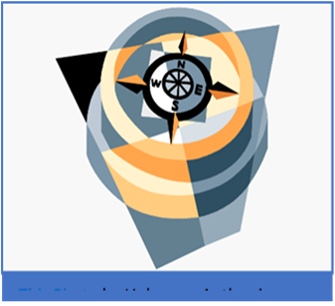
NWCCF 51st ANNUAL CONFERENCE
NOV 12-13, 2020 10am-3pm
NAVIGATING THE NEW NORMAL

WE ARE VIRTUAL!
This is the only conference designed specifically for the Washington, Oregon, and Idaho private postsecondary education Community.

REGISTRATION FORM:
Register below or visit www.nwcareercolleges.org for more conference information and online registration
Attach additional names.
Name______________________________________________________________ School__________________________________
Email_________________________________________________________
Address_____________________________________________City________________________________State__________Zip_____________
Phone__________________________________
All Access Registration: $99.00 (Certificate included in all registrations) Bundle (up to 6 participants single campus) $499.00

PAYMENT INFORMATION Completed form must accompany payment information:
Number of Registrations: ______ TOTAL DUE: $_________ □ Check Enclosed (see address below)
Please Charge My Credit Card for the Amount Above:
Card Number: _____________________________________________Name on Card: ____________________________________________ Exp Date:_______

Cancellation
Cancellation by the attendee after November 1, 2020, obligates the attendee to full payment of registration. No refunds will be made after this date. If written cancellation on or prior to November 1, 2020, a refund minus a 20% administration fee will be issued.
RETURN FORM TO:
Northwest Career Colleges Federation
700 Sleater Kinney Rd SE STE B369
Lacey, WA 98516
Scan and email: maryann@nwcareercolleges.org
Questions or Register by phone? 360-259-1313

