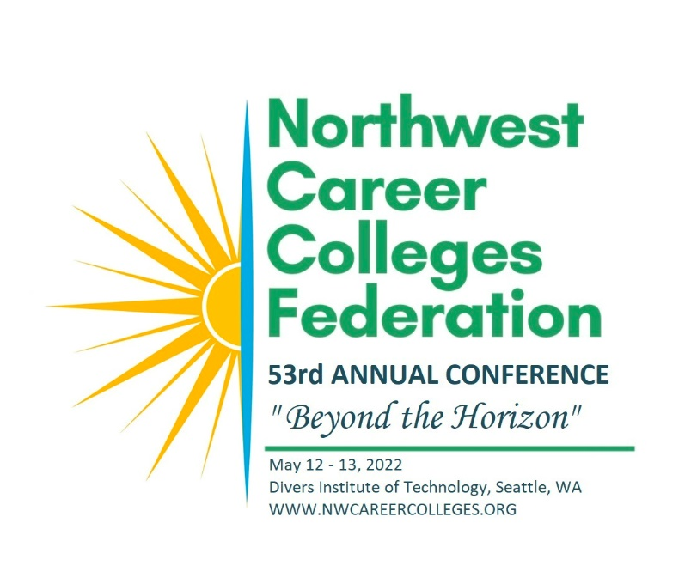
WE LOOK FORWARD TO SEEING YOU THERE!
This is the only conference designed specifically for the Washington, Oregon, and Idaho private postsecondary education Community.
REGISTRATION FORM:
Register below or visit www.nwcareercolleges.org for more conference information.
Attach additional names.
Name______________________________________________________________ School__________________________________
Email_________________________________________________________
Address_____________________________________________City________________________________State__________Zip_____________
Phone__________________________________
Registration:
Single Day Registration: $89.00 (non-member $99.00) Two Day Registration: $149.00 (non-member $169.00) State Agency: $129.00 Bundle (up to 6 people single campus) $759.00
PAYMENT INFORMATION Completed form must accompany payment information:
Number of Registrations: ______ TOTAL DUE: $_________ □ Check Enclosed (see address below)
Please Charge My Credit Card for the Amount Above:
Card Number: _____________________________________________Name on Card: ____________________________________________ Exp Date:_______
Cancellation
Cancellation by the attendee after May 1, 2022, obligates the attendee to full payment of registration. No refunds will be made after this date. If written cancellation on or prior to May 1, 2022, a refund minus a 20% administration fee will be issued. The safety of our guests is a priority. We reserve the right to implement safety protocols and will follow COVID-19 guidelines.
RETURN FORM TO:
Northwest Career Colleges Federation
700 Sleater Kinney Rd SE STE B369
Lacey, WA 98516
Scan and email: maryann@nwcareercolleges.org Questions or Register by phone? 360-259-1313

